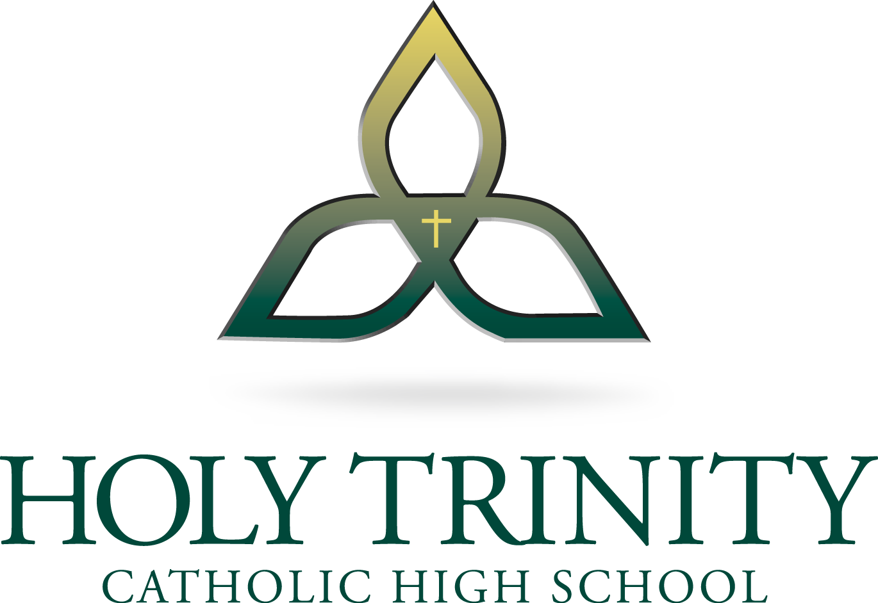
TEACHER: Mr. MacKinnon
ROOM: 152
EMAIL: bm4278@fmcsd.ab.ca

Welcome to…

Health/Religion 8

Course Description

This course examines the relationship between the person and message of Christ. Central to this course are the themes of believing, celebrating, living a moral life, living in communion, living in solidarity, and praying. Beginning with your own life experiences, seen in light of the Gospel narratives, you will acquire a deeper and more systematic knowledge of Christ, his message, and his Church. In addition, you will explore a variety of topics related to the themes of personal health, interpersonal relationships, and sexuality.

Units of Study

Unit No. | Religion | Themes
Unit 1 | We Believe in the Holy Spirit | 1-4
Unit 2 | We Believe in the Holy Church | 5-7
Unit 3 | We Believe in One Holy Catholic and Apostolic Church | 8-9
Unit 4 | We Believe in the Communion of Saints | 10-11
Unit 5 | We Believe in the Forgiveness of Sins | 12-15
Unit No. | Health | Themes
Unit 1 | Wellness Choices | 1-3
Unit 2 | Relationship Choices | 3-5

Assessment and Evaluation Guidelines

A wide range of assessment opportunities allows you to demonstrate your learning in different ways. Your marks will be calculated using the following categories:

Writing Assessments (30%) | Performance Assessments (30%) | Unit Tests (20%) | Final Assessment (20%)

EVALUATION CRITERIA

SUMMATIVE
Students Demonstrate Understanding of Curricular Outcomes
Grade Outcome Represents Final Understanding of Course Material
FORMATIVE
In-Class Activities, Practice, Homework, Small Assignments, Group Work, Check-Ups, etc.
Quizzes, Tests, Major Projects, Unit Exams,

- Formative work is mandatory. All formative work must be completed in order for students to be successful on summative assessments. Failure to complete formative work will result in any combination of the following:
  - mandatory after school or lunch extra-help tutorial
  - ineligibility to participate in summative assessment rewrites
  - on-campus reassignment
  - loss of spare until work is complete (grade 12 only)

- Summative work is mandatory. If a student fails to complete a summative assignment, he or she will be required to come up with a reasonable plan for completing the assigned work. Parent contact will be made should the student fall short of the agreed upon plan. If the assigned work continues to be outstanding on day three, the student will be placed in on-campus reassignment until the work is completed. Failure to complete summative work will result in any combination of the following:
  - mandatory after school or lunch extra-help tutorial
  - on-campus reassignment
  - parent/teacher/student/administrator meeting
  - student performance contract
  - course removal

REQUIRED RESOURCES

Stand By Me Textbook (Provided)
Sexuality Booklet (Provided)

